**Assignment 01 - Collection Framework**

1) Write a program to calculate the Simple Interest with minimal code using features of Java 11. Hint: Use the concept of functional interface and Local variable syntax for lambda parameters.

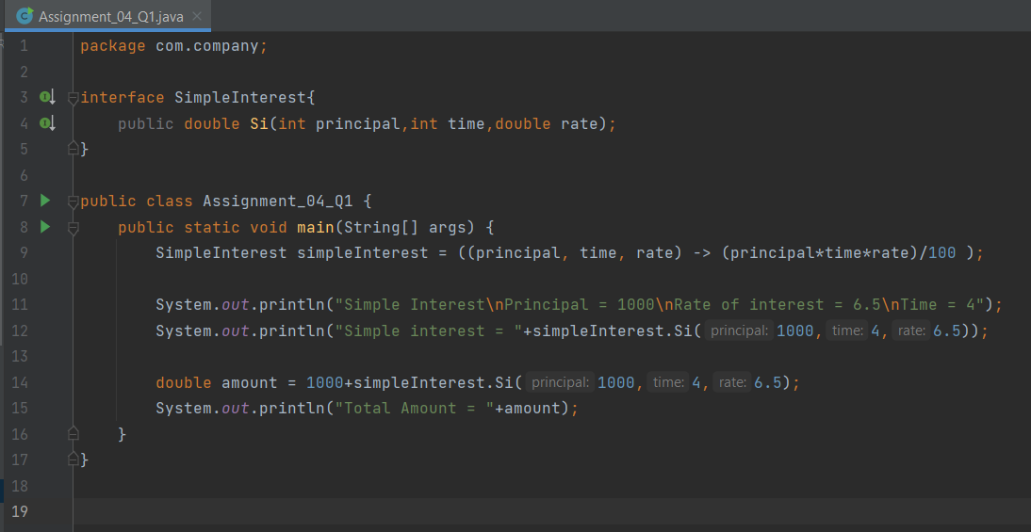

OUTPUT :

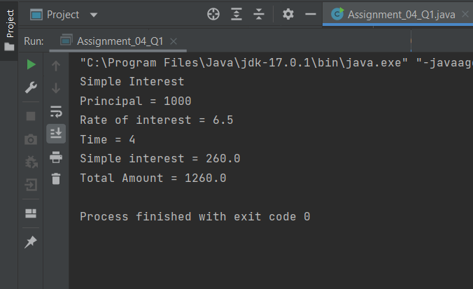

2. Java 11 supports var keyword for variable declarations. List the scenarios where var keyword cannot be used for such variable declarations. Give reason in support of your answer for each scenario.

• ‘var’ can be used only for local variables (in methods). It cannot be used for instance variables (at class level).

• We cannot use ‘var’ in Lambda expressions.

• We cannot use ‘var’ for method signatures (in return types and parameters).

3. “A quick brown fox jumps over the lazy dog”. Create an ArrayList from the given String. Such an ArrayList should include each word from the given sentence. Finally convert such List to an array using Java 11 methods and print the output.

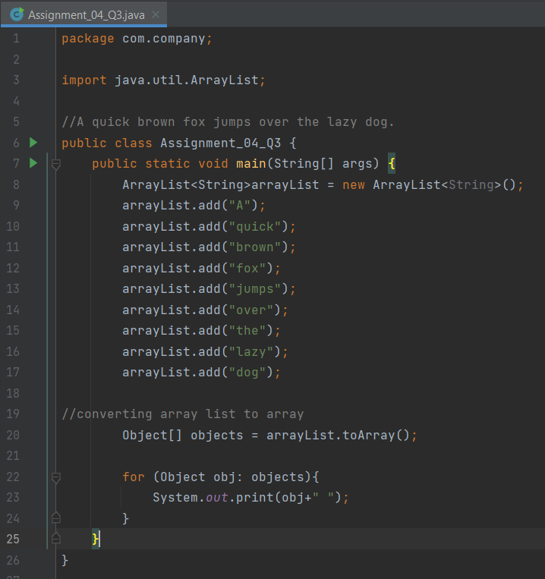

OUTPUT :

